Ordinance 01-19

AN ORDINANCE ENTITLED, an ordinance to amend Section 4.24.05.6 [Concentrated Animal Feeding Operation Control Requirements] in Article IV General Requirements, adopted by Ordinance 01-14, as amended of the Zoning Ordinance of Clark County.

BE IT ORDAINED BY THE BOARD OF COUNTY COMMISSIONERS OF CLARK COUNTY, SOUTH DAKOTA: that Article IV General Requirements, adopted by Ordinance 01-14, as amended, of the Zoning Ordinance of Clark County be amended by adding the following terms highlighted in bold and underline font and removing the items in strikethrough font:

6. Required Minimum Setbacks and Separation Distance for New Concentrated Animal Feeding Operations and those Existing Concentrated Animal Feeding operations without a County-issued permit expanding into a new Class A, B, C, or D, Concentrated animal Feeding Operations after (date of adoption of new ordinance). See Table 4.24-2

TABLE 4.24-2
MINIMUMS

CLASS A CLASS B CLASS C CLASS D & E
(2,000 or more) (1,000 to 1,999) (300 to 999) (10 to 299)

Established Residences 2,640 feet 2,640 feet 2,640 feet 1,320 feet
Plus one (1) Plus one (1)
Foot for each Foot for each
Addl. AU over Addl. AU over
1,000 AU 1,000 AU

Churches, Businesses and 2,640 feet 2,640 feet 2,640 feet 1,320 feet
Commercially Zoned Areas plus 440 ft
For each
Addnl. 1,000
AU over
2,000 AU

Incorporated Municipality 10,560 feet 5,280 feet 2,640 feet 2,640 feet
Limits, Carpenter & Crocker plus 440 feet
for each addnl.
1,000 AU
over 2,000

Lakes and Streams 500 feet 200 feet 200 feet 200 feet
classified as Fisheries as
identified by the State

Federal, State & County Road
ROW 330 feet 330 feet 330 feet 200 feet

Township Road ROW 330 feet 330 feet 330 feet 200 feet

Designated Flood Plain Prohibited Prohibited Prohibited Prohibited
Public Water Supplies 1,000 feet 1,000 feet 500 feet 500 feet

Private Shallow Wells 250 feet 250 feet 250 feet 250 feet
Other than the operator*

* Private wells meeting the definition of an abandoned well shall not be considered in determining the above minimum setback and separation distances.

Separation Distances and Setbacks^{1, 4}

 | Number of Animal Units | 10 to 299 Animal Units | 300 to 999 Animal Units | 1,000 to 1,999 Animal Units | 2,000 to 4,999 Animal Units | 5,000 to 9,999 Animal Units | Over 10,000 Animal Units
SEPARATION DISTANCES | Established Residences ^{2,3} | 1,320 feet | 2,640 feet |  |  | 3,960 feet | 5,280 feet
 | Churches, Businesses and Commercially Zoned Areas³ | 1,320 feet | 2,640 feet |  |  | 3,960 feet | 5,280 feet
 | Incorporated Municipality Limits, Carpenter, & Crocker³ | 2,640 feet | 5,280 feet |  | 10,560 feet plus 440 feet for each additional 1,000 animal units over 2,000 animal units | 11,800 feet plus 440 feet for each additional 1,000 animal units over 5,000 animal units | 14,000 feet plus 440 feet for each additional 1,000 animal units over 10,000 animal units
 | Federal, State, County, and Township Right-of-Way | 200 feet | 330 feet
SETBACKS | Established Private Water Well^{5,6} | 250 feet
 | Existing Public Water Well | 500 feet |  | 1,000 feet
 | Lakes and Streams classified as Fisheries as identified by the State | 200 feet |  |  | 500 feet
Designated Floodplain |  | PROHIBITED

¹ Two (2) or more CAFOs under common ownership are a single concentrated animal feeding operation if they adjoin each other (within one mile) or if they use a common area or system for disposal of manure. Required setbacks for the two (2) or more CAFOs treated as a single operation shall not be less than the suggested minimum setback required for each operation if said operations were treated as individual operations.
² Established residences do not include any residence established after March 18, 1997 and less than one-half (1/2) mile from any Concentrated Animal Feeding Operation which was active at the time of the residence’s construction.
³ The Board of Adjustment may allow a setback of less than the minimum required provided a written waiver by the entity deriving the benefit of the setback is filed with the application.
⁴ The Board of Adjustment may utilize Section 4.24.05.7 to increase or decrease the setbacks and separation distances.
⁵ Established private water wells refer to wells used as a source of potable water for human consumption one (1) year prior to application date for the proposed CAFO or expansion.
⁶ Setback does not apply to the wells of the CAFO operator.

7. Separation Distance Requirements Exemptions to Separation and/or Setback Distance Requirements

a. A concentrated animal feeding operation that satisfies any of the criteria below shall be exempt from the applicable separation or setback distance with no variance required by the Board of Adjustment.

- A Concentrated Animal Feeding Operation which is expanded or constructed less than the suggested setback from a right-of-way (ROW) provided approval of the applicable road authority is submitted to the zoning officer prior to issuance of any applicable building permits or stocking of the Concentrated Animal Feeding Operation if no building permits are required. County Highway Department (County right-of-way), Township Board of Supervisors (Township right-of-way), or State Department of Transportation (state right-of-way) are authorized to provide approval on behalf of the respective road authority. Other entities may provide approval on behalf of the listed entities if documentation of their authority to grant such approval is submitted.

- All Concentrated Animal Feeding Operations in operation prior to January 1, 2019 which do not comply with the suggested minimum setback/separation requirements, but continue to operate, and are not expanded in a manner which will result in the one of the following examples are exempt from suggested separation distance:

  - Example 1: A Class E CAFO expands to a Class A, B, or C CAFO.

  - Example 2: A Class C CAFO expands to a Class A or B CAFO.

  - Example 3: A Class B CAFO expands to a Class A CAFO.

  - Example 4: A Class A CAFO expands by 10% of the number of animal units

Provided, that the expansion does not further encroach the setback/separation distance existing on January 1, 2019. See Figure 4.24.5.7.

- A Concentrated Animal Feeding Operation which is expanded or constructed, if the title holder of the land benefitting from the distance separation requirement executes a written waiver with the title holder of the land where the Concentrated Animal Feeding Operation is located, under such terms and conditions which the parties may negotiate. The title holder of the land benefitting from the distance separation requirement is the residence, commercial enterprise, individual or individuals, governmental entity, religious institution, or educational institution from which separation is required. The waiver shall be binding upon the heirs, successors, and assigns of the title holder and shall pass with the land.

- A Concentrated Animal Feeding Operation which is constructed or expanded closer than the suggested setback/separation distance from the corporate limits of a community, if the incorporated community approves a written waiver.

- A Concentrated Animal Feeding Operation which existed prior to the creation of a residence, educational institution, commercial enterprise, religious institution, incorporated community, if the residence, educational institution, commercial enterprise or religious institution was constructed or expanded or the boundaries of the incorporated community were expanded, after the date that the concentrated animal feeding operation was established. The date that the Concentrated Animal feeding Operation was established is the date on which the Concentrated Animal Feeding Operation commenced operating. A change in ownership or expansion shall not change the date of operation.

- Any Concentrated Animal Feeding Operation in operation as of January 1, 2019 which does not comply with the suggested minimum setback/separation distance requirements is allowed to be replaced in the event of a calamity without obtaining a variance. Provided, that the replacement does not further encroach the setback/separation distance existing at the time of the calamity. See Figure 4.24.7.

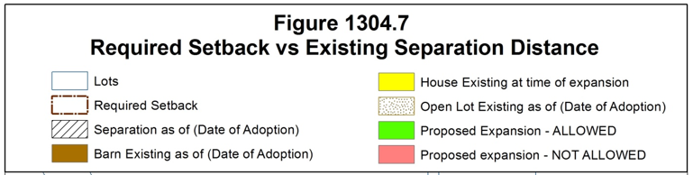
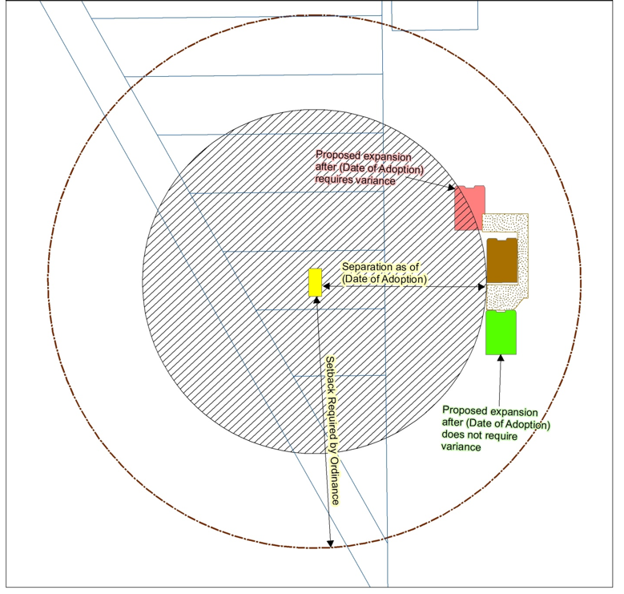
FIGURE 4.24.7
Each application for a new or expanded Concentrated Animal Feeding Operation (CAFO) will be reviewed by the board of Adjustment on a site-specific basis. In granting a conditional use, the Board of Adjustment may determine one (1) or more of the following considerations warrant an increase in setbacks and separation distances.reserves the right to increase or decrease the minimum required setbacks and separation distance on a site specific review based on one (1) or more of the following considerations:

a.i. Considerations To Increase Suggested Setbacks And Separation Distances

i.a. A concentration of Concentrated Animal Feeding Operations in the area exists or would occur which may pose an air or water quality concern.

ii.b. Due to topography and/or prevailing wind direction, additional setback and separation distance is appropriate to safeguard air or water quality. The South Dakota Odor Footprint Tool may be utilized to determine the need to increase setback and/or separation requirements.

iii.c.A Concentrated Animal Feeding Operation is in excess of five thousand (5,000) animal units.

iv.d.Review of past management practices and proposed improvements to manure handling facilities.

b.ii In granting a conditional use, the Board of Adjustment may determine one (1) or more of the following considerations warrant a decrease Suggested in setbacks and separation distances

The Board of Adjustment may reduce recommended setback/separation distances of any new or existing Concentrated Animal Feeding Operation proposing to expand based upon any or all of the following considerations:

i.a. Public input relating to the setback or separation distance variance requested;

ii.b. Site specific review dealing with drainage, topography, and wind direction; and

iii.c. Review of the operation of the Concentrated Animal Feeding Operation as it pertains to the type of manure handling system and manure application methods to be used would not require conformance with suggested setback and separation distances as outlined herein;

iv.d. An existing Concentrated Animal Feeding Operation proposes to expand but does not meet suggested setback or separation distances, the Board of Adjustment may reduce suggested setbacks and separation distances after review of past management practices and proposed improvements to manure handling facilities;

v.e. Due to the type of manure handling and management of the CAFO little or no impact on adjacent property is expected. The use of Bio-filters, neoprene lagoon covers, and/or methane digesters are examples of improvements which may result in the reduction of recommended setbacks and separation distances. The South Dakota Odor Footprint Tool may be utilized to determine the need to decrease setback and/or separation requirements;

vi.f. Due to topography and/or prevailing wind direction little or no impact on adjacent property is expected. The South Dakota Odor Footprint Tool may be utilized to determine the need to decrease setback and/or separation requirements;

vii.g.By limiting the proposed expansion to specific number of animal units no adverse impacts are expected. The South Dakota Odor Footprint Tool may be utilized to determine the need to decrease setback and/or separation requirements;

c. Exceptions to Separation Distance Requirements.

- All Concentrated Animal Feeding Operations (CAFO) in operation prior to March 18, 1997, which do not comply with the minimum setback requirements, but continues to operate, and are not expanded in a manner which will result in the one of the following examples are exempt from setback/separation distance requirements:

  - Example 1: A Class E expands to a Class A, B, C, or D CAFO.
  - Example 2: A Class D CAFO expands to a Class A, B or C CAFO.
  - Example 3: A Class C CAFO expands to a Class A or B CAFO.
  - Example 4: A Class B CAFO expands to a Class A CAFO.
  - Example 5: A Class A CAFO expands by 15%.

- A Concentrated Animal Feeding Operation which is expanded or constructed, if the title holder of the land benefitting from the distance separation requirement executes a written waiver with the title holder of the land where the CAFO is located, under such terms and conditions which the parties may negotiate. The written waiver becomes effective only upon the recording of the waiver in the office of the Register of Deeds in the county. The title holder of the land benefiting from the distance separation requirement is the residence, commercial enterprise, bonafide religious institution, or educational institution from which separation is required.

- A Concentrated Animal Feeding Operation constructed or expanded closer than the required setback/separation distance from the corporate limits of a city, if the incorporated community approves a written waiver. The written waiver becomes effective only after its recording with the Register of Deeds.

- A Concentrated Animal Feeding Operation which existed prior to the creation of an educational institution, commercial enterprise, bonafide religious institution, or incorporated community or the expansion thereof, is exempt if the educational institution, commercial enterprise or bonafide institution was constructed or expanded or the boundaries of the incorporated community were expanded, after the date that the animal feeding operation was established. The date that the Concentrated Animal feeding Operation was established is the date on which the Concentrated Animal Feeding Operation commenced operating. A change in ownership or expansion shall not change the date of operation.

Passed and adopted this 1st day of October, 2019.

__________________
Chairperson

___________________
Auditor

Public Hearing Notice Publication September 4, 2019
Planning Commission Public Hearing and Recommendation: September 24, 2019
County Commission Public Hearing and First Reading: September 24, 2019
County Commission Second Reading and Approval: October 1, 2019
Publication: October 9, 2019
Effective: October 29, 2019

*dates in italic font are projected and subject to change

