**Clark County**

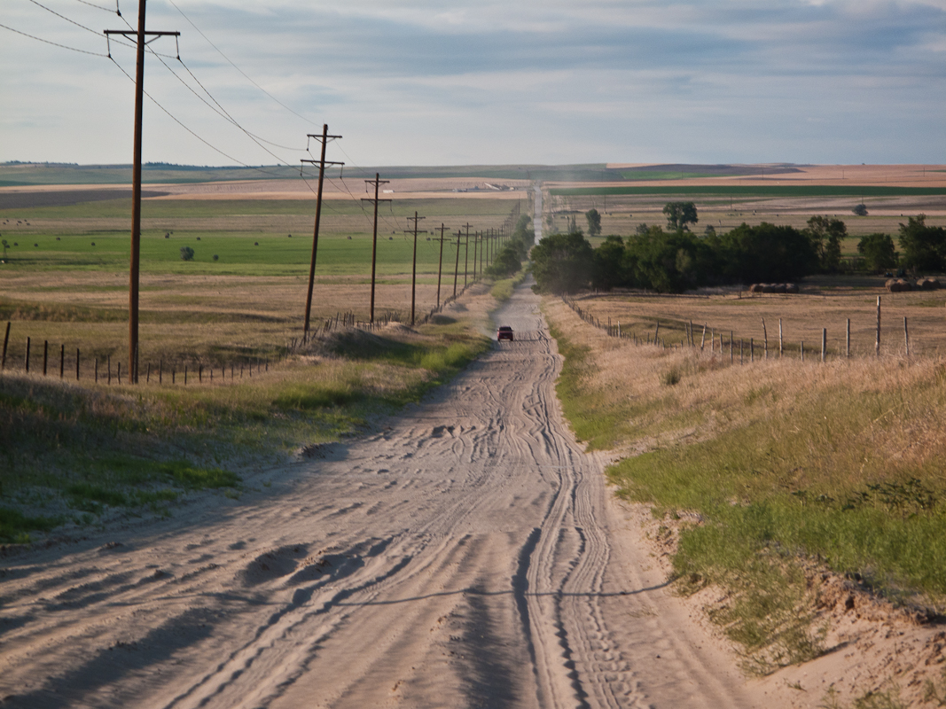

Five-Year County Highway and Bridge Improvement Plan

**Dot Approval Letter**

**Certification Form**

**CHECKLIST OF REQUIREMENTS FOR ANNUAL UPDATE**

____X___ Certification Form

____X___ Projected Revenue Available per year

____X___ 5-year Project List (Programmed Projects)

____X___ Project Status List

____X___ Affidavit of publication of public meeting notice (copy of the notice or article

alone, is not sufficient)

____X___ Township coordination letters/notice (sample letter and mailing list is acceptable)

____X___ Attendance list from public meeting (all attendees – not just commission members)

____X___ Public Comments (if no comments are received, clearly indicate that in the plan submittal)

**Table of Contents**

What is the Five-Year County Highway and Bridge Improvement Plan?

Development of the Plan

What is in the Plan?

Appendix

Project Needs List

Revenue Source Table

Five-Year Project Location Map

Five-Year Project List

Project Status List

Sample of Coordination Letter Sent to Township Officials

Township Officials Mailing List

Affidavit of Publication for Notice of Public Meeting

Public Meeting Attendance List

Comments from Public Meeting

Clark County Resolution of Adoption

**What is the Five-Year County Highway and Bridge Improvement Plan?**

Transportation planning is a cooperative process designed to foster involvement by all users of the system, such as the business community, community groups, the traveling public, freight operators and the general public through a proactive public participation process conducted by the county. The planning process also fosters communication of local governments such as townships, towns and larger cities to jointly discuss transportation needs and coordinate improvements.

The Clark County Five-Year County Highway and Bridge Improvement Plan (Plan) is a short-range planning document that will be developed and updated annually based on needs and identified Clark County transportation policies. The plan will include roadway classifications, roadway and bridge inventory, a five-year list of the projected revenue for highway and bridge improvements, a five-year list of programmed highway and bridge projects based on the projected revenue, and the status of programmed projects from the previous plan.

The Plan is to be used as a tool to assist the county in budgeting, planning and incorporating the needs and concerns of the public.

**Development of the Plan**

Clark County developed this plan with assistance from the First District Association of Local Governments. Projects identified in the plan Projects were generated from many sources including elected officials, studies, inventory management systems, local knowledge, staff members and other interested individuals and groups.

Once the programmed project list was developed, Township officials and the public were invited to a coordination/public meeting to provide an opportunity for public comment. That meeting was noticed in the Clark County Courier newspaper and held on September 17, 2020. Based on the results of the Township/public meeting and comments from the County Commission, a final version of the Plan was developed by the First District. This final version was then adopted by the County Commission on October 6, 2020.

**What is included in the Plan?**

The Plan includes the following information:

**1. Map (See Appendix)**

The following map is included in the Appendix.

* **Five-Year Project Location Map**
  + The Five-year Project Location Map shows the location proposed identified in the five-year programmed project list.

**2. Lists/Tables (See Appendix)**

* **Project Needs List**
* To help in programming five years of projects, the County created a list of all the highway and bridge needs in the county. This list includes a project location, project description with an improvement type (reconstruction, maintenance, surfacing, structure replacement or rehabilitation) and a project estimate. Projects contained in the project needs list are organized according to project need based on input from public leaders, staff and the general public. The needs are ranked as high, medium or low priority. The needs list helps to show the public and elected officials the needs in the county.
* In developing the list of needs, the County considered traffic generators such as schools, grain terminals, large dairies, ethanol plants, etc. and the impacts from the traffic generators. The County also considered safety issues. Examples of safety projects are narrow or non-existent shoulders, pavement markings, blind corners, sharp curves, steep side slopes and poor sight distance. The County also considered system needs such as preservation of existing facilities. Preventive maintenance is typically applied to pavements in good condition having significant remaining service life. As a major component of pavement preservation, preventive maintenance is a strategy of extending the service life by applying cost-effective treatments to the surface or near-surface of structurally sound pavements. Examples of preventive treatments include asphalt crack sealing, chip sealing, slurry or micro-surfacing, thin and ultra-thin asphalt overlays, concrete joint sealing, diamond grinding, dowel-bar retrofit, and isolated, partial and/or full-depth repairs.
* The needs list identifies problems or deficiencies and explores possible solutions.
* Some of the needs may be short-term, and some may be long-term. The long-term needs may require several projects in order to complete.
* **Project List (Five-year programmed project list based on projected funding)**

* The Project List is based on projected revenue available. It includes project location, project description with improvement type, funding source(s) and a planning level or engineer's estimate.
* The projects contained in the project list are organized according to programmed year and are based on needs and input from public leaders, staff and the public. The programmed projects will show what projects can be done with the funding available.
* Portions of a project may be unfunded. A portion of the project cost planned for the five years included in the Plan may include grant funding which has been or will be applied for, but not yet approved.
* Bridge Improvement Grants include Preliminary Engineering Grants, Bridge Rehabilitation Grants and Bridge Replacement Grants.
* Equipment is often a large portion of the transportation budget and is considered when evaluating project selections.
* **Projected Revenue Table (Five-year budget projection for highway and bridge program)**
* The Plan projected revenue table identifies the amount of funds projected to be available for highway and bridge use over the next five years.
* The table includes non-confirmed but potential revenue sources such as grant funds which may or may not have been applied and for which confirmation has not yet been received.
* Planned expenditures for each project are summarized into funding categories. The

funding categories reflect anticipated revenue sources.

* **Revenue Sources** – This includes the following types of funding categories:
* **Local Funds–** The taxes levied portion of the revenue estimates includes a variety of funding sources, including wheel tax, property tax, motor vehicle licenses, etc.
* **Intergovernmental Revenue –** The Intergovernmental sources of revenue includes charges for services for townships and road districts.
* **State Funds** - These are any revenues from the state for highway purposes including Bridge Improvement Grants (BIG), Exchange for Surface Transportation Program (STP) Funds, Agri-Business Grants, etc.
* **Federal Funding** - Federal funding is available through various programs included in Federal transportation legislation. SDDOT administers most of these programs. They include Emergency Relief (ER), Federal Emergency Management Agency (FEMA), Surface Transportation Program Funds, Transportation Alternative Program (TAP), Safety funds, County-Wide Signing Projects, etc.
* **Other –** Miscellaneous funding sources include transfer of general funds, sale of surplus property, and others that do not fit into the categories above.
* **Project Status List**
* The Project Status List is a review of the status of projects from the previous year.

**APPENDIX**

**Project Needs List**

**Revenue Source Table**

**Five-Year Project Location Map**

**Project List (Five-year programmed project list based on projected funding)**

**Project Status List**

**Sample of Coordination Letter sent to Township Officials**

**Affidavit of Publication for Notice of Public Meeting**

**Township Officials Mailing List**

**Public Meeting Attendance List**

**Comments from Public Meeting**

**Clark County Resolution of Adoption**

|  |  |  |  |
| --- | --- | --- | --- |
| **Project Needs List** | | | |
| **Project Location** | **Project Description** | **Total Project Cost** | **Prioritization Ranking**  **(Optional)** |
|
|  |  |  |  |
| Various Locations | Annually Seal Coat 40 Miles | 500 | High |
| Various Locations | Annually Overlay Patch 5,000 Tons Hot Mix | 500 | High |
| Various Locations | Annually Gravel 50 Miles | 300 | High |
| 13-023-230 | Bridge Replacement | 425 | High |
| 13-050-212 | Bridge Replacement | 400 | High |
| CR17 | Reconstruct and Overlay | 12,250 | High |
| Various Locations | Bridge Inspections | 3 | High |
| Various Locations | Striping Oil Roads | 40 | High |
| Various Locations | Annually Replace 2 Large Culverts by County Crews | 100 | Medium |
| CR36 | Mill and Overlay | 1,200 | Low |
| CR6 | Mill and Overlay | 2,400 | Low |

**Revenue Source Table**

**(Show amounts in thousands of dollars)**

|  |  |  |  |  |  |
| --- | --- | --- | --- | --- | --- |
| **Account Description** | **2021** | **2022** | **2023** | **2024** | **2025** |
| **Local Funds** |  |  |  |  |  |
| General Funds-property tax | 2809 | 2837 | 2871 | 2928 | 2972 |
| Motor Vehicle Licenses | 925 | 925 | 940 | 940 | 940 |
| Wheel Tax | 152 | 152 | 154 | 154 | 154 |
| Annual STP Payout Funds | 180 | 180 | 180 | 180 | 180 |
| **Intergovernmental Funds** |  |  |  |  |  |
| Township Services |  |  |  |  |  |
| **State Funds** |  |  |  |  |  |
| BIG – PE (planning to apply for) |  |  |  |  |  |
| BIG – PE (awarded by DOT) |  |  |  |  |  |
| BIG – Preservation (planning to apply for) |  |  |  |  |  |
| BIG – Preservation (awarded by DOT) |  |  |  |  |  |
| BIG – Construction (planning to apply for) | 660 |  |  |  |  |
| BIG – Construction (awarded by DOT) |  |  |  |  |  |
| Match on STP Projects. |  |  |  |  |  |
| **Federal Funds** |  |  |  |  |  |
| TAP |  |  |  |  |  |
| ER/FEMA |  |  |  |  |  |
| OTHER (STP, Bridge, Signing, Hazard Elimination, SIB Loans) |  |  |  |  |  |
| **TOTAL** | 4066 | 4094 | 4145 | 4202 | 4246 |

**Note:**

* General Funds – Property Tax includes a .79 cent per $1,000 levy for road projects per SDCL 10-12-13

**FIVE-YEAR PROGRAMMED PROJECT LISTING**

|  |  |  |  |  |  |  |  |  |  |
| --- | --- | --- | --- | --- | --- | --- | --- | --- | --- |
| **Project Location** | **Project Description** | **Year** | **Proposed Five-Year Project Funding Information (in thousands of dollars)** | | | | | | **Total Project Cost** |
| **Local**  **Funding** | **Federal**  **Funding** | **State**  **Funding** | **Unfunded** | **Anticipated**  **Grant** | **Total**  **Funding** |
|  |  |  |  |  |  |  |  |  |  |
| 13-023-230 | Bridge Replacement | 2021 | 85 |  | 340 |  | 340 | 425 | 425 |
| 13-050-212 | Bridge Replacement | 2021 | 80 |  |  |  | 320 | 400 | 400 |
| Various Gravel Roads | Gravel | 2021 | 300 |  |  |  |  | 300 | 300 |
| Various Oil Roads | Overlay Patch | 2021 | 400 |  |  |  |  | 200 | 200 |
| Various Oil Roads | Chip Seal | 2021 | 500 |  |  |  |  | 500 | 500 |
| Various Gravel Roads | Gravel | 2022 | 300 |  |  |  |  | 300 | 300 |
| Various Oil Roads | Overlay Patch | 2022 | 500 |  |  |  |  | 500 | 500 |
| Various Oil Roads | Chip Seal | 2022 | 500 |  |  |  |  | 500 | 500 |
| Various Gravel Roads | Gravel | 2023 | 400 |  |  |  |  | 400 | 400 |
| Various Oil Roads | Overlay Patch | 2023 | 500 |  |  |  |  | 500 | 500 |
| Various Oil Roads | Chip Seal | 2023 | 500 |  |  |  |  | 500 | 500 |
| Various Gravel Roads | Gravel | 2024 | 400 |  |  |  |  | 400 | 400 |
| Various Oil Roads | Overlay Patch | 2024 | 500 |  |  |  |  | 500 | 500 |
| Various Oil Roads | Chip Seal | 2024 | 500 |  |  |  |  | 500 | 500 |
| Various Gravel Roads | Gravel | 2025 | 400 |  |  |  |  | 400 | 400 |
| Various Oil Roads | Overlay Patch | 2025 | 500 |  |  |  |  | 500 | 500 |
| Various Oil Roads | Chip Seal | 2025 | 500 |  |  |  |  | 500 | 500 |

**Local Funding Includes:** Match on BIG funding, traditional BRO & BRF projects, TAP projects, etc., and some shortfalls/balances on misc. projects. Also STP Payout funds.

**Federal Funding Includes:** 100% of Signing & Delineation projects, and approx. 80% of STP, BRO, BRF, and TAP projects. Federal portion of ER/FEMA projects.

**State Funding Includes:** 80% of awarded BIG projects and approx. 20% match on STP projects.

**Anticipated Grant (BIG):** 80% of total

**Project Status List**

|  |  |  |  |
| --- | --- | --- | --- |
| **Project Location** | **Annual Listing of Programmed Projects**  **Project Description** | **Year** | **Status** |
|  |  |  |  |
| Various Gravel Roads | Gravel | 2020 | Projects completed |
| Various Oil Roads | Overlay Patch | 2020 | Projects completed |
| Various Oil Roads | Chip Seal | 2020 | Projects completed |
| 13-010-225 | Bridge Replacement | 2020 | Replacement Grant awarded – Project is complete |
| 13-023-230 | Bridge Replacement | 2020 | Replacement Grant Denied – Project moved to 2021 |
| 13-050-212 | Bridge Replacement | 2020 | Replacement Grant Denied – Project moved to 2021 |

**Five-Year Project Location Map**

**(See Attached)**

**Sample of Coordination Letter sent to Township Officials**

**Township Officials Mailing List**

**Affidavit of Publication for Public Hearing**

**Public Meeting Attendance List**

**Public Meeting Minutes/Comments from Public Meeting**

No changes to the plan as a result of the public hearing.

**Clark County Resolution of Adoption**